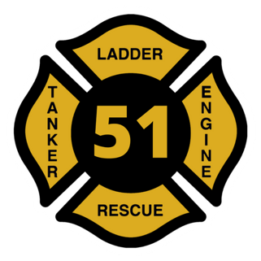
Pennington Fire Company
Santa Clause Gift Delivery Form

Event Details: Once again this holiday season, Santa Clause has asked Station 51 to help deliver gifts in our district. With so many children in the Pennington area, he desperately needs our assistance and of course our members are ready for the task. If interested in getting a special visit from Santa and a truck from our fleet packed with some of our members, please fill out the form below.

Price: delivery is a minimum $20 donation per household. All donations will go to the building fund.

When: Pre-wrapped gifts must be dropped off at our firehouse on December 3rd, 4th, and 5th between 5:30 PM and 9:00 PM along with this form completed with proper information. Gifts must include child's name, age, and address. Gifts will be delivered on December 12th, 13th, and 14th between 5:30 PM and 9:00 PM.

______________________________________________________________________________

Child’s First Name: __________________________________________________

Child’s Last Name: __________________________________________________

Child’s Age: ___________________________________________________

Delivery Address: ___________________________________________________

Phone Number: ___________________________________________________

